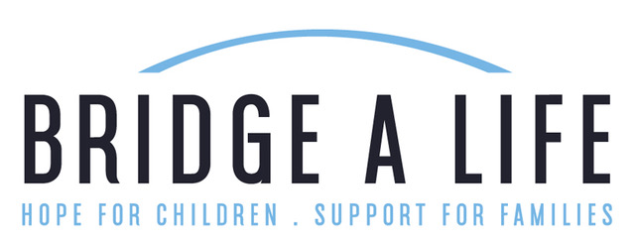

Beatrice Fund- Adoption Assistance Program
Bridge a Life exists to “share Christ-centered hope with children who have been abused, orphaned, abandoned, or neglected while supporting foster and adoptive families through awareness, training, outreach, and partnerships.”
We understand that some families encounter financial hurdles when navigating the adoption process. In addition to other support programs, Bridge a Life desires to help families meet their financial obligations regarding adoption.

About The Beatrice Fund
The Beatrice Fund Adoption Assistance Grant is available to any 12th Circuit Florida resident (Sarasota, Manatee, and DeSoto Counties) who has an approved and current home study from a licensed and accredited adoption agency. International and domestic adoptions will be considered. Grants are awarded regardless of race, age, or marital status. Applicants must be professing Christians who are members in good standing with a local church community. Due to limited funding, we cannot guarantee all qualified applicants will receive a grant.

Please consider the following below applying:
+Your adoption has not already been fully funded (Bridge a Life grants cannot be used as reimbursements for expenses already paid).
+Your adoption has not been finalized.
+You have a completed home study.
+You are a resident of the 12th Circuit in Florida.
+You are able to provide a reference letter from your church’s staff/clergy.
+You are working with a Hague-accredited agency (for international applicants).

Beatrice Fund- Amounts:
Bridge a Life does not fully fund adoptions but can assist with a small portion of the expenses. Adoption assistance amounts range from $250-1,500. Funds will be awarded directly to your adoption agency on your behalf.

How to Apply:
Complete the following application (with family story). Submit application along with proof of approved current home study and a reference letter from your church staff/clergy.

Beatrice Fund Adoption Assistance Application

Applicant #1 Name
Address
Phone Number
Email Address
Birthday
Social Media User Names (Twitter/Facebook/InstaGram)
Applicant #2 Name
Phone Number
Email Address
Birthday
Social Media User Names (Twitter/Facebook/InstaGram)

Church Name
Church Address
Church Website
Church Phone Number
Pastor/Staff Member’s Name
Pastor/Staff Member’s Email

Country/State from where you are adopting
Name of Adoption Agency
Website of Adoption Agency
Address of Adoption Agency
Phone Number of Adoption Agency
Name of Case Manager
We’d love to know a little more about you! What led to your decision to adopt? Do you have other children? Why should you be considered for the Beatrice Fund? What can you tell us about the child you’ve been matched with? Anything else you’d like us to know? Please share your story in 300-700 words.

Please submit this completed application (with family story) along with proof of approved current home study and a reference letter from your church staff/clergy stating that you are a current member/attendee in good standing.

